**GIT & GITHUB**

**File Push From Git To Github:**

Go to localrepository directory and open the gitBash  
1. create directory  
2. cd to the new created director  
3. create a new file : touch demo.txt  
4. git init :---> curr directory  
5 git add demo.txt  
6 git commit -m message  
7. git remote add origin <https://github.com/Rpriyadharshini2732/Torry-Harris-training.git>

8. git removte -v  
9. git push origin master

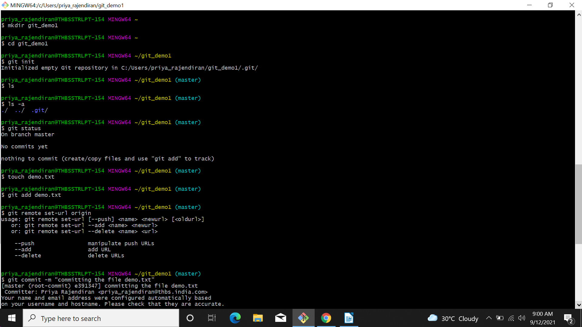

**Output:**

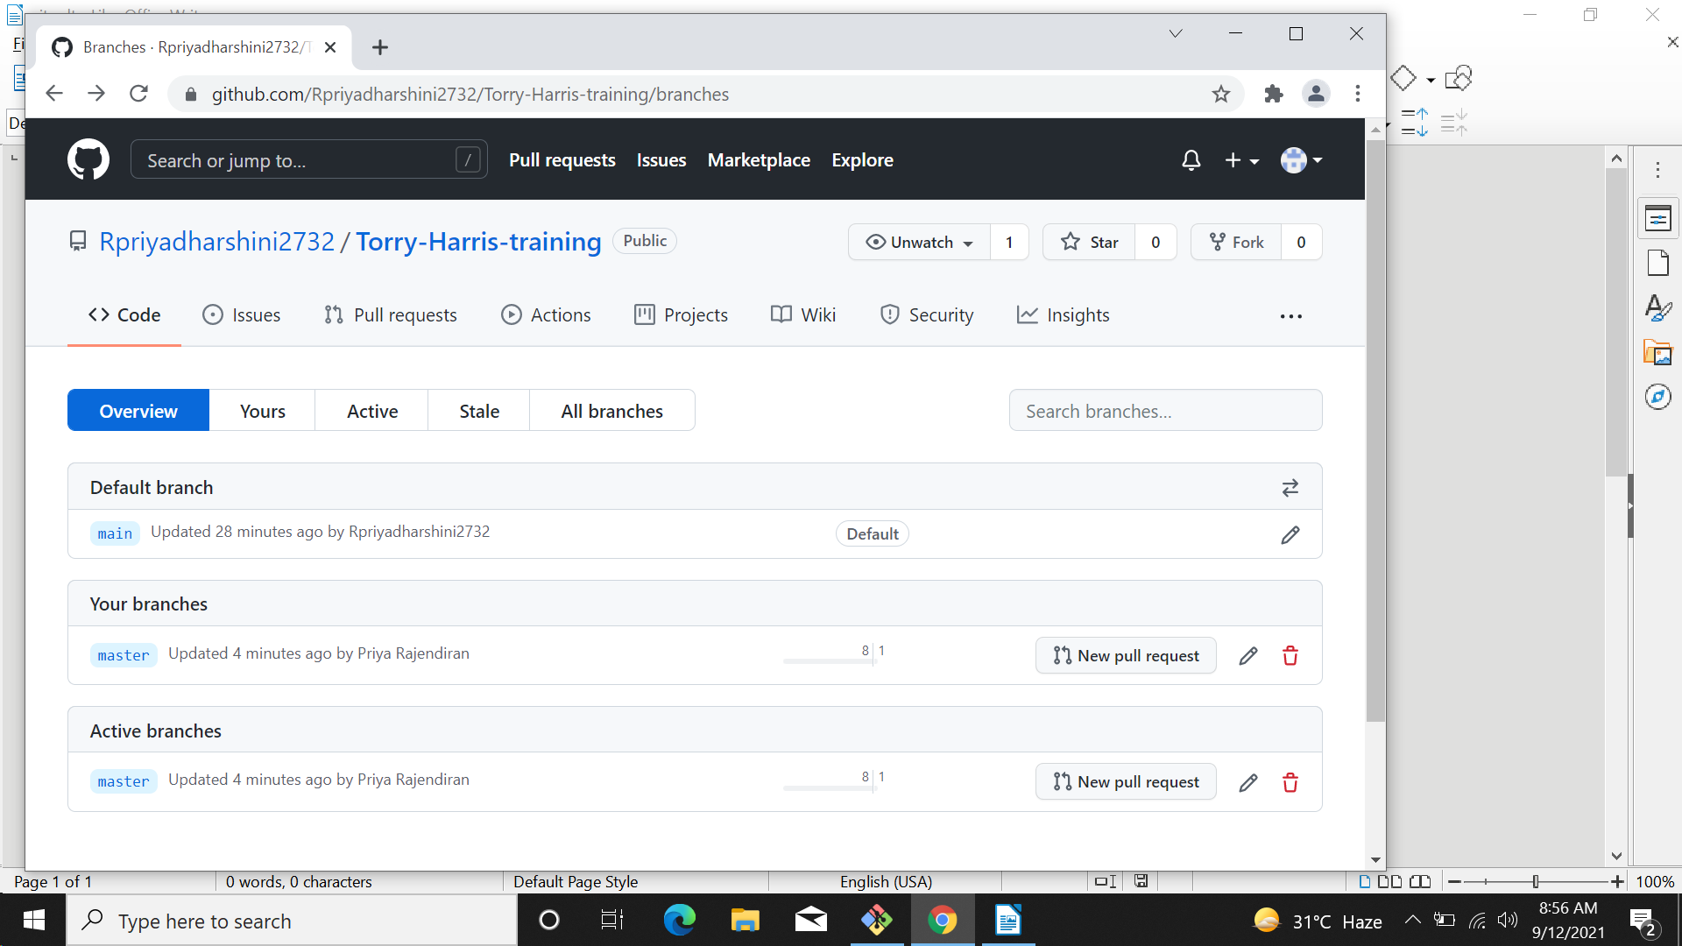

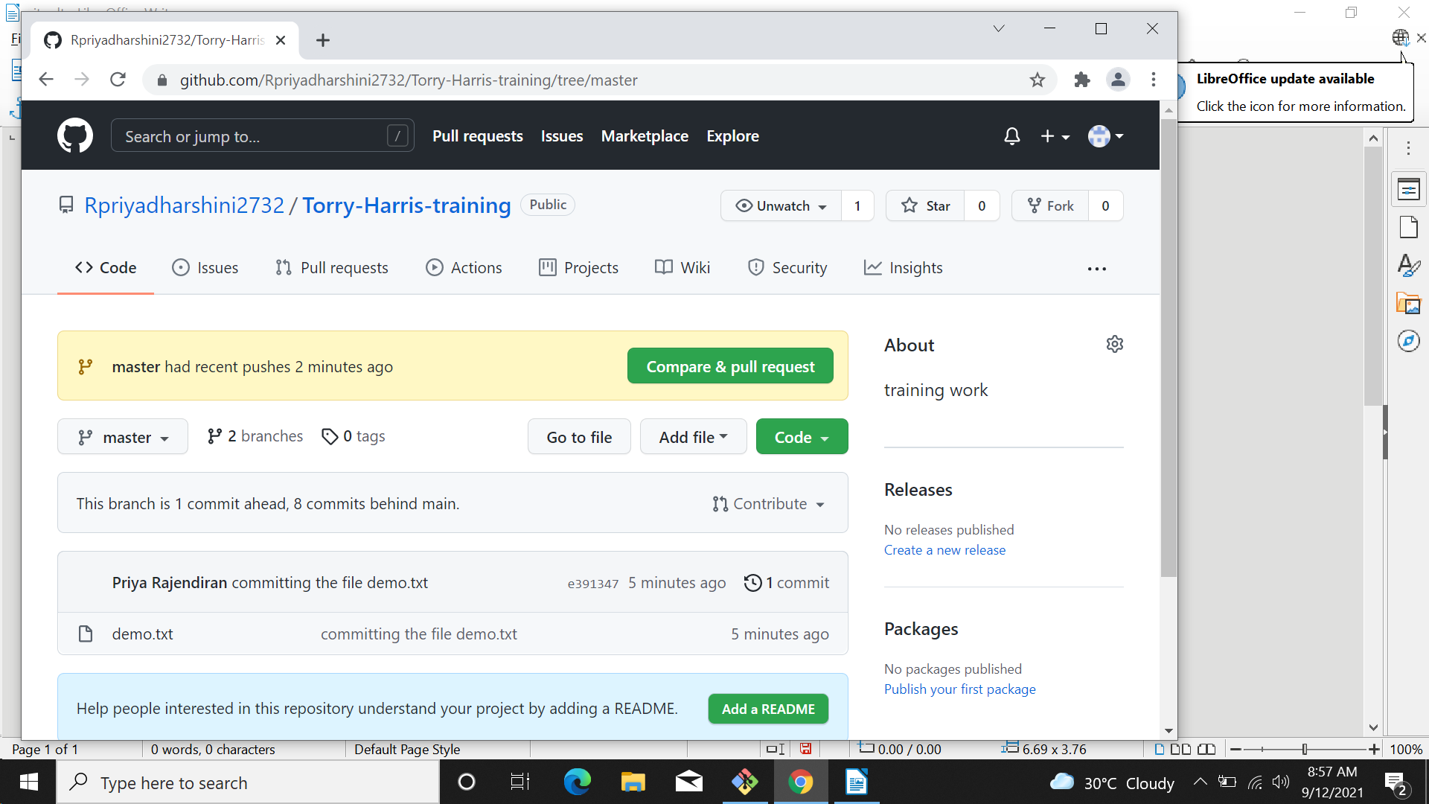

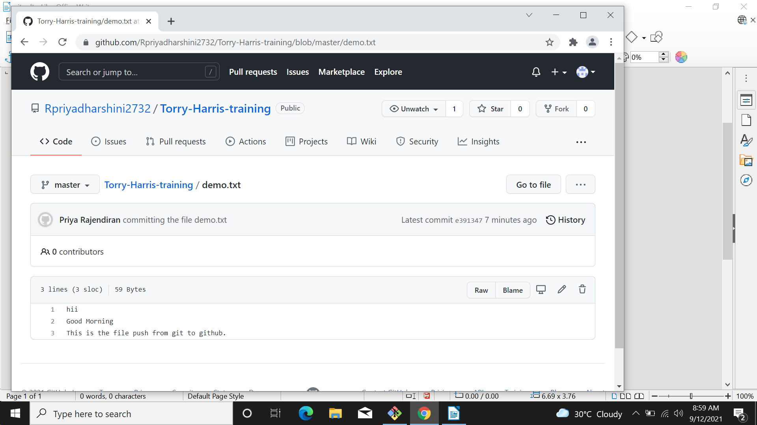

**File Pull From Remote Repository**

1. git init newfromgithub  
2. git pull https://github.com/Rpriyadharshini2732/Torry-Harris-training.git

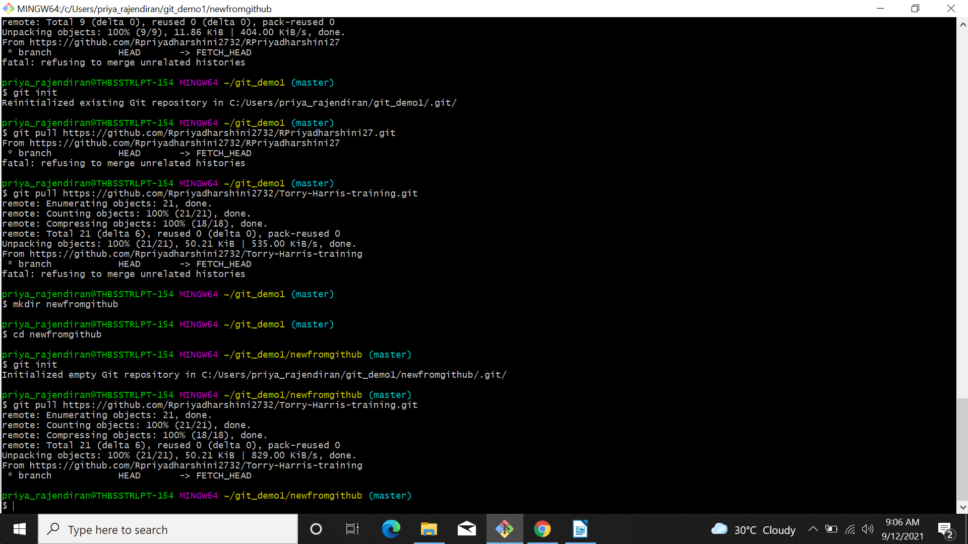

**Output:**

